**Lab 1**

**Name: -** Aryan Dilipbhai Langhanoja

**Date:-** 11-07-2023

**Enrollment No:-** 92200133030

**CO1: To write, test, and debug simple Python programs**

**CO2: To implement Python programs with conditional, loops and functions**

**Task 1: Printing on screen**

**Python Code:**

print('Hello World')

print(5)

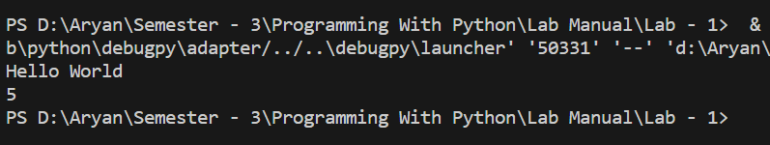**Output:**

**Task 2 : to end any string with any specific character.**

**Python Code:**

print("Hello World",end='!')

print("\nICT")

**Output:**

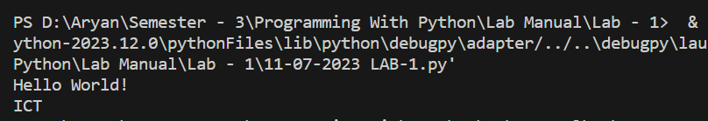

**Task 3:** assiging the value

**Python Code:**

a = 6

print(a)

a,b = 8,8

print(a)

print(b)

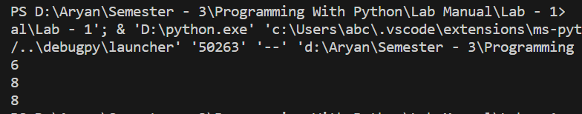**Output:**

**Task 4:** Checking the different data types

**Python Code:**

c = "5"

print(type(c))

d = 5.5

print(type(d))

d = 2 + complex(3)

print(type(d))

**Output:**

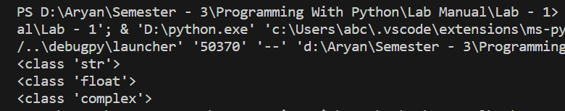

**Task 5 : taking input from user**

**Python Code:**

num = input("Enter Number:-")

print(num)

print(type(num))

**Output:**

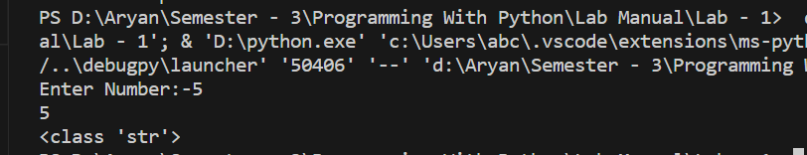

**Task 6: Concate the string**

**Python Code:**

b = "Department"

print("My Department Name Is " + b)

**Output:**

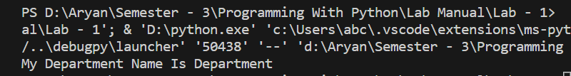

**Task 7: abstrcting the character of strings via indexing**

**Python Code:**

print(b[0])

print(b[0:3])

print(b[len(b) - 4 : len(b) + 1])

print(b[0::])

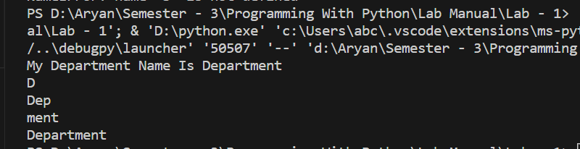**Output:**